**Module 3: Docker Part 1**

**Assignment – 2**

1. Created an image using the container ID created in assignment – 2

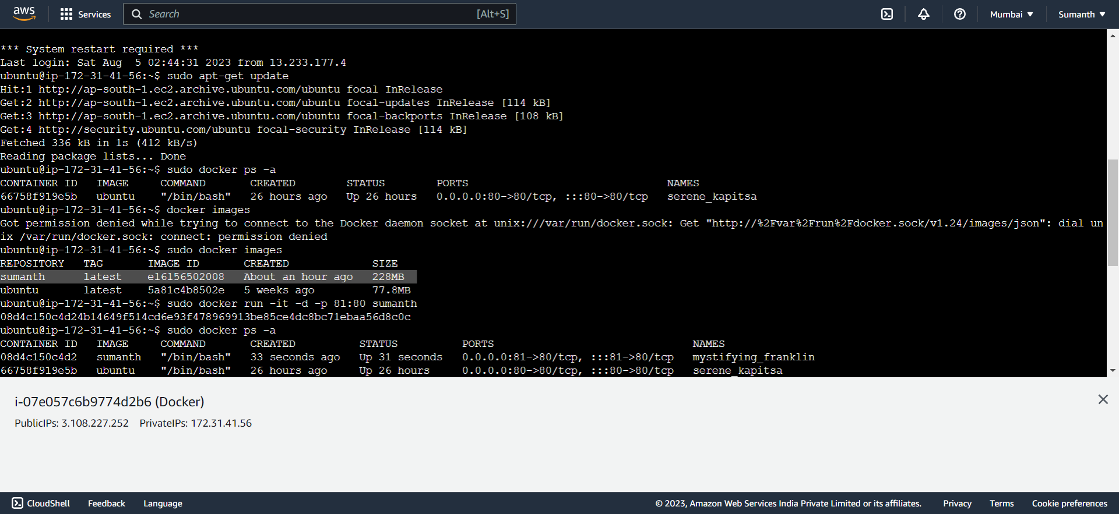

1. Launched a new container from the new image and mapped the port to 81

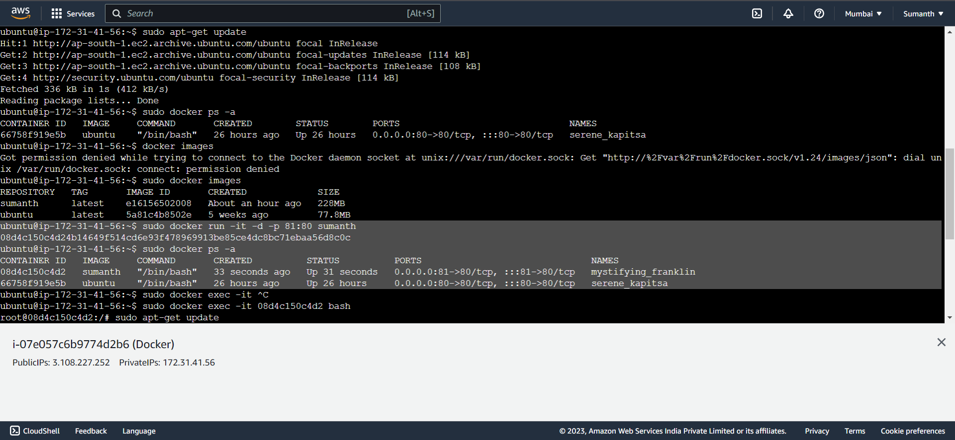

1. Went inside the container and started the Apache2 service

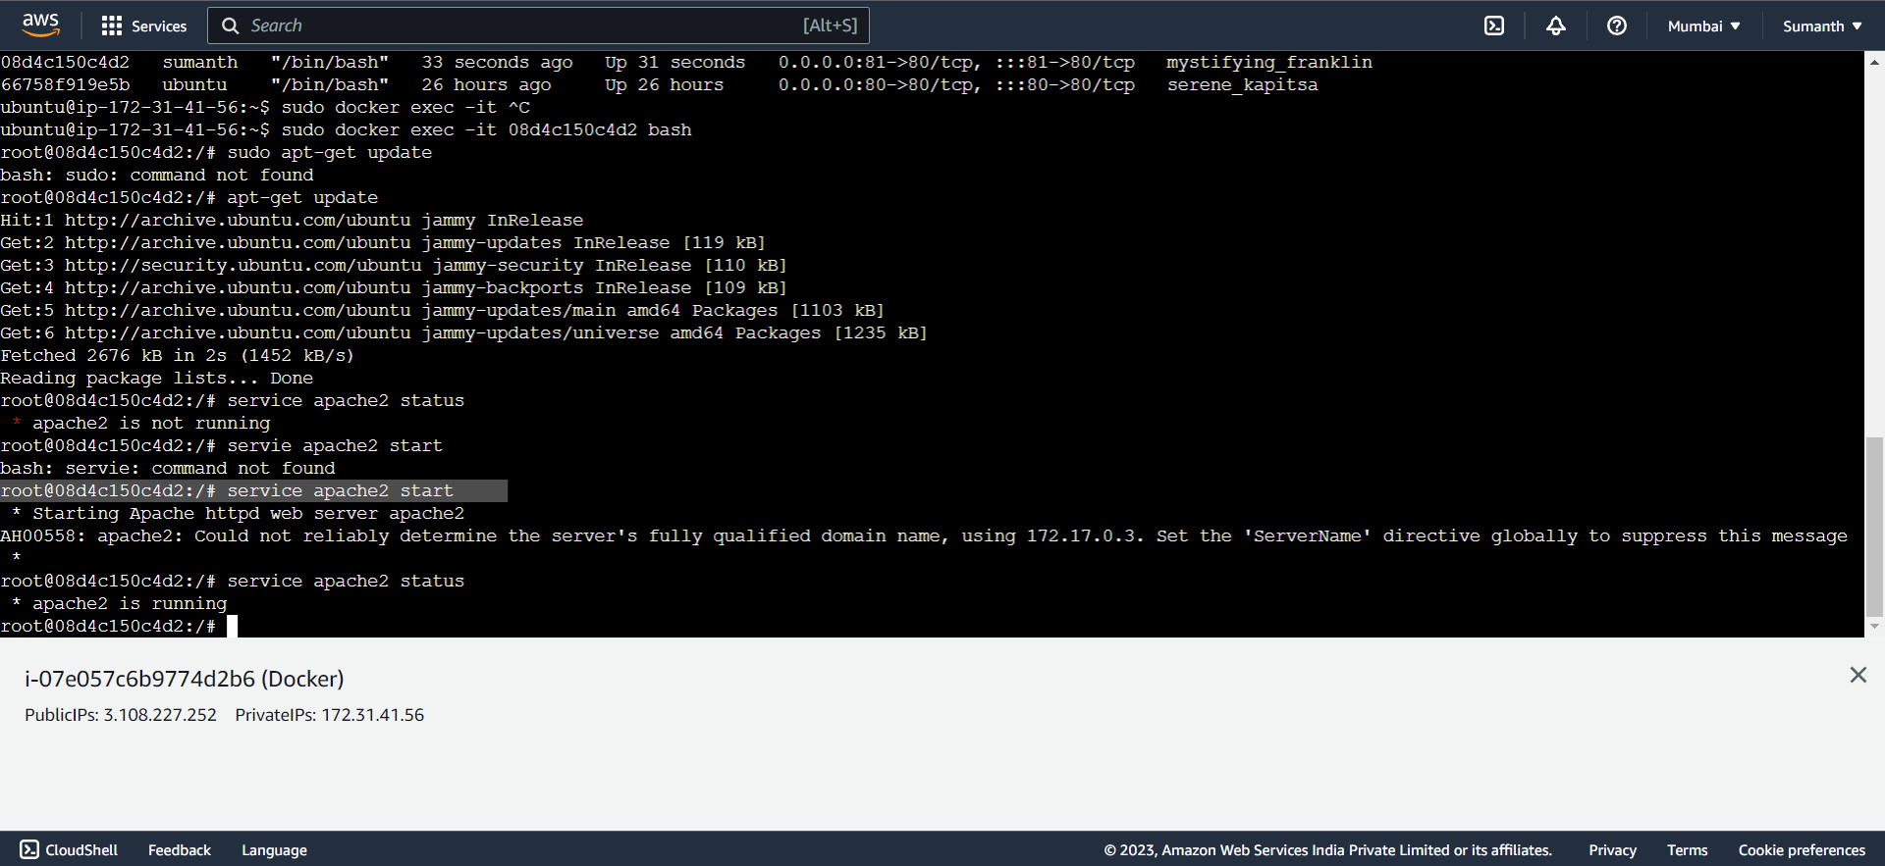

1. Able to access it in the browser

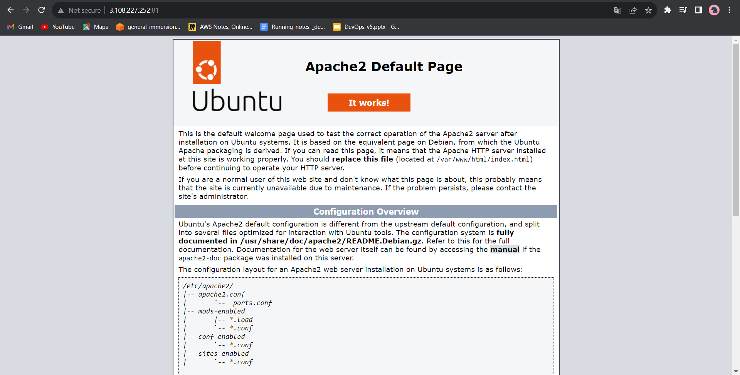

1. Commands used for the assignment

sudo docker ps -a

14 sudo docker commit 66758f919e5b sumanth

15 sudo docker images

16 sudo docker run -it -d -p 81:80 sumanth

17 sudo docker ps -a

18 sudo docker exec -it 08d4c150c4d2 bash

service apache2 status

service apache2 start